PARENT-PROVIDER
POLICIES
AND
PROCEDURES

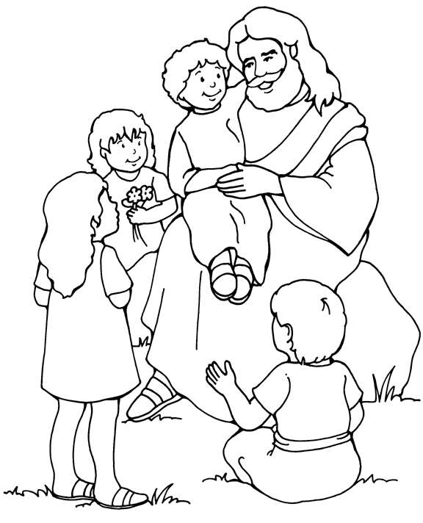

Harmony-Zelienople
Global Methodist Church
Child Care Center

123 North Pittsburgh Street
Zelienople, PA 16063

(724) 766-2444 Center’s Wireless
(724) 452-9724 Center’s Land Line
(724) 452-7670 Church

Lynda Johnston, Director
(724) 766-2445 Wireless

Revised July 2024

Welcome

Welcome to the Harmony-Zelienople Global Methodist Church Child Care Center. We hope your whole family will enjoy the center and the friends you will make here. This handbook has been written to describe our program, goals, policies and the myriad of practical details that go into making each day at the center as happy and successful as possible. Please read through this and keep it for reference, as it will answer many of your questions.

Statement of Purpose

This child care center was established in September of 1992 as an outreach ministry of the Harmony-Zelienople Global Methodist Church. Its purpose is to meet the needs of the community by nurturing children in a Christ-centered environment and to promote a safe, secure and loving atmosphere in which each child may develop and grow emotionally, socially, intellectually, physically and spiritually by receiving a well-rounded experience.

Nondiscrimination in Services

Admission to the center, the provision of services and referrals of families shall be made without regard to race, color, religious creed, disability, ancestry, national origin, age or sex. Program services shall be made accessible to eligible individuals with disabilities through the most practical and economically feasible methods available. These methods include but are not limited to equipment redesign, the provision of aids, and the use of alternative service delivery locations. Structural modifications shall be considered only as a last resort among available methods. Any child and/or their guardian who believes they have been discriminated against may file a complaint of discrimination with any of the following:

Harmony-Zelienople Global Methodist Church
123 N. Pittsburgh Street
Zelienople, PA 16063

Department of Human Services
Bureau of Equal Opportunity
Room 225, Health and Welfare Building
P.O. Box 2675
Harrisburg, PA 17110

U.S. Dept. of Health and Human Services
Office of Civil Rights
Suite 372, Public Ledger Building
150 S. Independence Mall West
Philadelphia, PA 19106-9111

PA Human Relations Commission
301 Fifth Avenue
Suite 390, Piatt Place
Pittsburgh, PA 15222

Commonwealth of PA
DHS/Bureau of Equal Opportunity
Western Regional Office
301 Fifth Avenue
Suite 410, Piatt Place
Pittsburgh, PA 15222

Admission Process

The provider requires all perspective families to visit the Center with the child before enrolling. It is important that all of those involved be comfortable with the child care arrangements. Once the decision to attend the Center has been made, any applicable registration fee and/or holding fees must be paid to guarantee placement of your child at the Center.
There are several forms that must be completed prior to the first day of attendance at the Center. They include an emergency contact/parental consent form, an agreement form for financial responsibilities, an insurance waiver and an “All About _______” information sheet. The child health assessment form must be completed by your child’s physician and turned in within thirty days after enrollment.
Parents are to notify the provider of any changes in emergency information such as telephone numbers, place of employment, home address and insurance policy numbers, which may differ from that recorded when the child enrolled at the center. This is to be done on an “as needed” basis or a minimum of every six months. Your child’s file must be updated at least twice a year in order for us to be in compliance with State Regulation 3270.181c. Since this is strictly enforced by the state, parents will be required to either complete new paperwork or do a periodic review signature during the last two weeks of January, May and September to ensure we don’t go beyond the every six months requirement.

Operating Hours and Holiday Policy

The Center is open Monday through Friday, from 7:00am to 5:30pm except for scheduled holidays and any emergency closings. The Center will be closed on the following holidays:

New Year’s Day Good Friday Memorial Day July 4th Labor Day Thanksgiving & the day after Christmas Eve thru New Year’s Eve

In general, if any of the above holidays fall on a Saturday, the center will be closed on Friday and if it is on Sunday, we will be closed on Monday. These are paid holidays for the provider, which means that if a holiday falls on a day you are contracted to use, you are required to pay for that day also. A list of all holidays and scheduled closed days will be given to parents in November for the upcoming calendar year. The list will also show whether or not the day is considered a paid holiday or not.

Scheduling

The parent and the provider will agree on a set schedule of when the child is to attend and when the child is to be dropped off and picked up. When attending part-time, we require your child to be enrolled at the center for a minimum of two full days or three half days. We offer a three day/week schedule of Monday, Tuesday, Thursday. The two day/week schedule is Wednesday, Friday. The half day schedule is 8:00am – 1:00pm and is only available to those in the preschool room. Attending the center four or five days a week is considered fulltime. Occasional changes or additions to your child’s schedule may be made with approval from the provider if space is available and with additional fees applied. Any permanent changes in your child’s schedule MUST be agreed upon by both the parent and the provider and recorded on the agreement form. Payment rates will be adjusted accordingly.

Drop-off and Pick-up

Parents are required to park in the side lot. Because of bus traffic to CVE, do not park along Pittsburgh Street. The first 4-6 parking spaces in the parking lot on the side adjacent to the fence will be left open for your use. Parents are required to turn your car off and take the keys out of the ignition. For safety reasons, parents are also required to escort their child in and out of the center in a controlled manner. Warn your child about the dangers of running in the parking lot. Teach them to walk with you and to watch where they are going.
When dropping off children, parents need to allow enough time to assist the child in hanging up their coat, putting their lunch in the refrigerator, and signing the child in. Please make sure your child’s caregiver knows your child has arrived.
When picking up children, parents should make sure the staff are aware that the child is leaving and sign out the child. If someone other than the parent is to pick-up a child, a written, signed note should be given to the director advising of this change. Be sure the designated pick-up person has proper photo identification, such as a driver’s license, to show upon arrival. Children will not be released to someone other than a parent without proper notification from the parent and without proper identification being shown.

Absences

Parents are to notify the provider if the child is going to be absent for any reason. In the case of vacation, the parent will notify the provider two weeks in advance for any full week absence.

Withdrawing Your Child

Parents who wish to withdraw their child from the Center should notify the provider two weeks in advance of their last day. If the provider is not notified in advance, an additional charge for the two weeks will be incurred. The provider reserves the right to remove the child from care if:
- The child is physically or verbally abusive to the other children or the staff, as determined by the provider. (See Chronic Disruptive Behavior for more information.)
- The child fails to adjust to the center, as determined by the provider.
- The provider is unable to meet the developmental or special needs of the child, as determined by the provider.
- The parent fails to abide by the Center’s policies and procedures.
- The parent is physically or verbally abusive to the other children or the staff.
- The parent fails to pay the provider the fees agreed upon for care.



Fees for Services

The following is a list of all the various fees that may be charged for child care services. Parents will be given at least two weeks notice of any changes or increases to these fees.

- Registration Fee - There is a one - time family registration fee of $35.00, which is non-refundable and due at the time enrollment forms are completed.

- Supply Fee – The center will collect a yearly supply fee during the month of October in the amount of $35.00 per child or $50.00 per family with multiple children. Parents will be notified in writing two weeks prior to when this fee is due.

- Placement Holding Fee - Families NEW to the center who wish to reserve a spot for their child at the Child Care Center will pay a holding fee of $50.00 per month with the center holding a spot for the child for a maximum of three months. The placement holding fee will not be applied to the new starting balance. In addition, if the family is not able to start their child on the agreed upon date but still wants to hold the spot, they will need to pay 25% of the normal weekly fee for each week the start date is delayed in order to keep the spot. If, after paying the placement holding fee, the child does not attend the center, the entire amount is forfeited.

- Holding Fee – Parents who wish to withdraw their child from the center for the summer, for a maternity leave, due to unemployment etc., will be required to pay 25% of their normal weekly payment per child per week that the spot is being held. This Holding Fee may be used once within a twelve month period for a minimum of four consecutive weeks up to a maximum of twelve consecutive weeks. The Holding Fee will not be applied to the normal weekly payment due upon return to the center. It will simply hold the spot for your child. This fee is to be paid before the child leaves the center for the designated time period and is non-refundable.

- Spring Fundraiser Non-participatory Fee – Parents of the center are strongly encouraged to participate in the spring fundraiser as it benefits the center and is a critical part of the yearly budget. If parents decide not to participate, they can opt instead to pay the non-participatory fundraiser fee of $50.00 per family.

- Full-Time Weekly Rates
Infant (6 weeks to 12 months old) - $368.00
Young Toddler (13 months to 24 months) - $343.00
Older Toddler (25 months to 36 months) - $326.00
Preschool (3 years to 6 years old) - $305.00

- Part-time Daily Rates (Based on more than five hours of care per day.)
Infant - $84.00 per day
Young Toddler - $76.00 per day
Older Toddler - $73.00 per day
Preschool - $67.00 per day

- Part-Time Half Day Rate (Between the hours of 8:00am-1:00pm only)
Preschool - $41.00 per day

The fee for the youngest member of the family will be as per the age group of the
child. There is a 10% discount off of the fee for the oldest child.

Payments

All parents are required to pre-pay for child care services. Payments are due on Monday, or on the first day of the week that your child attends, by 5:30pm. If you pay monthly, your payment is due by the first Monday of the month. For convenience, consider having a check payment sent automatically from your bank to the child care center. There is a $15.00 service charge for each check returned by the bank due to insufficient funds. Checks are to be made payable to: HZGMC Child Care Center.
Parents will be responsible for paying for child care services that they contract for regardless of whether or not their child is at the center. This includes if they were off due to illness, visiting grandma, on vacation or just having a stay at home day with a parent.
The provider will document all payments received from the parent. A copy of the payment record with our tax identification number will be provided to the parents by January 31st each year so you may claim it on your federal taxes. In addition, if a parent participates in any pre-tax child care reimbursement plans available through their employer, the provider will upon request assist with any extra documentation needed such as written receipts for each payment.

Overtime Charge

The Center closes at 5:30pm each day. If you are not at the center by 5:30pm to pick up your child, you will be charged a late pick-up fee of $5.00 for each interval of fifteen minutes you are late. If you call to inform us you will be late, you will be charged $3.00 for each fifteen - minute interval. Late pick-up fees are to be paid directly to the provider on the date incurred. If the fee is not paid on the date incurred, the late fee will be added to your regular weekly payment amount. Overtime charges will be enforced.

Program Overview

The children will be introduced to a balanced program of interaction with friends in both teacher-directed and child-directed experiences. The daily schedule includes free play, group times for creative movement, music, storytelling and dramatization. A variety of play materials and equipment will be available to the children. Many different themes and units will be presented in the toddler and preschool rooms which align with the Pennsylvania Learning Standards for Early Childhood to help prepare your child for kindergarten. Self-help and independence is fostered in all possible ways. Weather permitting, the children will take neighborhood walks and play outside in our play area or at the Zelienople Community Park. The children will also be exposed to Bible stories and songs on a regular basis.

Parent - Provider Communication

The provider and the parents must stay in close communications at all times. It is imperative that parents understand and support the policies and procedures that are expected in the center, including the disciplinary actions that the child will receive when those behaviors are not observed. For this reason, the parent-provider communication channel is open and honest. Parents will be informed either verbally or in writing of any unusual occurrence affecting the child. In turn, it is also important that the parents inform the provider of any situation at home that may adversely affect the child’s stay at the center. Parents may call the provider at anytime to discuss problems or concerns.

Center Evaluation

Parents will be asked occasionally to complete an evaluation of the center, its program, fees and our ability to meet your family needs. These are very important to us as they help us see where we need to improve. Please take the time to fill it out when it is received.

Your Child’s Adjustment

Naturally, your child will miss you. It may take your child some time to adjust to the provider and to the center. To help this situation, you should take the time to settle your child in by helping him take off his coat and hanging it up, putting his lunch box in the refrigerator, and helping him pick out a toy to play with but should try not to stay too long. Remember, a child’s crying usually stops about one minute after the parent leaves!

Assessing Your Child’s Development

We will be observing your child throughout the year to assess their development physically, emotionally, socially, and intellectually. Three times a year a written assessment form called the Child Service Report will be completed on each child. A parent-teacher conference will then be held to discuss your child’s growth and development within the context of the services provided. Parents may also request a parent-teacher conference at any time.
In addition, we try to have an outside agency, such as Lifesteps in Butler, come to the center at least once a year to do developmental screenings. This is a free service which parents may take advantage of by completing the permission slip and returning it to the center when a screening is being held. The agency will then send home an information sheet giving the results of the screening and any follow-up information that may be necessary.

Guidance and Discipline

At the center, we work with the children to develop internal control of their behavior. We help guide the children in making responsible choices and to accept the consequences of their choices. We do this by:
- Having logical rules, such as keep your hands to yourself, and then explain why such rules are needed.
- Having curriculum that is developmentally appropriate or that is based on the children’s interests and level of readiness.
- Reinforcing the behaviors we encourage the children to display. We let the children know when we like what they are doing. Catch them being “good”!
- Redirecting a child to another activity as needed to prevent a potentially difficult situation.
- Giving positive reminders of what we want the children to do rather than using “no” or “don’t”.
- Using “time out” or “renewal time”. Sometimes a child needs to be removed from the situation for a brief time to allow them to consider alternative or more appropriate behavior.
Any on-going situations will be discussed with the parents to ensure a cooperative approach. Please feel free to discuss any questions or concerns you may have with your child’s teacher or with the director.

Chronic Disruptive Behavior

We will make every effort to work with the parents of children having difficulties in child care. We are here to serve and protect all of our children though. Children displaying chronic disruptive behavior, which has been determined to be upsetting to the physical or emotional well being of another child, may require the following actions:

- Initial Consultation - The director may request the parent(s) of any child who attends the center to meet for a conference. The problem will be defined in writing. The director and the parent(s) will work together to establish behavioral goals and approaches toward reaching those goals.
- Second Consultation - If the initial plan for helping the child fails, the parents will again be requested to meet with the director. Another attempt will be made to identify the problem, outline new approaches to the problem, and discuss the need to schedule an appointment for a free developmental evaluation through PA’s Early Intervention System. Based on outcome of this evaluation, a Behavioral Evaluation and Supportive Services may also be needed. (Please refer to the resource included on the next page entitled “Are you concerned about your young child’s development and/or behavior? Learn what to do and who to call in Butler County” for steps to follow.)
- Discontinuation of Services - When the previous attempts have been followed including receiving help from outside resources and no progress has been made towards solving the problem, child care services may be discontinued with two week notice being given by the provider to the parent(s). In extreme cases, services may be discontinued immediately if at anytime the child exhibits uncontrollable behavior that cannot be modified by the child care staff or if parents are not making any attempts to seek outside help for their child and/or work with the staff of the center to correct the behaviors.

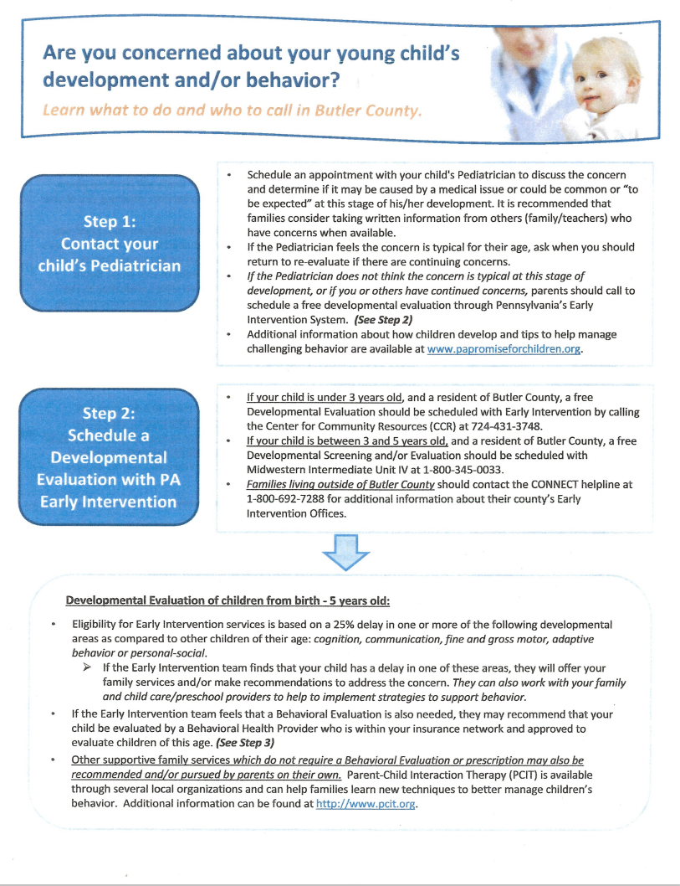



Meals

If you would like your child to eat breakfast at the Center, you must supply it. This can be your child’s favorite dry cereal or a hot instant variety such as Cream of Wheat or Oatmeal. The staff will let you know when the box is almost empty so that more may be brought in. You may also bring in pancakes, waffles, French toast, bread, bagels, English muffins, or any breakfast food that we can heat either in the toaster or microwave. We have condiments such as syrup, butter, jelly and cinnamon & sugar here for their use.
Parents must also provide a lunch for their child everyday while at the Center unless otherwise announced. Occasionally, we have pizza parties or special meals to celebrate the holidays. When we do, a small fee is charged to help cover the cost of the meal and you will not need to provide a lunch for your child. Please be sure to provide your child with a well-balanced diet, which includes fresh fruit and vegetables, whole wheat bread and low-sugar foods. If your child requires formula, commercial baby food or special milk other than 2% low fat milk, you are expected to provide these.
Your child will be encouraged to eat the main course item first, followed by the fruit and then snack or dessert type items. Milk and/or water will be supplied by the center at lunch.

Snack Sign-up

The children are offered snack twice a day, once in the morning around 9:30 and again after naptime, around 3:30. We have developed a snack calendar. Parents are required to donate items needed for the snack calendar on a monthly basis. A sign-up sheet is posted on the door as you enter the “kitchen area”. Parents should start helping to provide snack once their child is eating table food or when they enter the toddler room. Fruit juice, 2% milk and/or water will be provided by the Center.

Birthday Treats

Children are invited to celebrate their birthdays at school. If parents choose to bring in a birthday treat, please let the staff know of your intentions. We prefer birthday treats such as mini-cupcakes, cookies or ice cream cups. Sheet cakes and regular size cupcakes tend to be too much for the children to eat and we end up with more on the floor than in tummies.
The class will sing Happy Birthday and the birthday child may blow out the candles. Parents may send in their camera for the staff to take pictures if they desire or they may attend the mini-celebration.

Your Child’s Belongings

Please label all small stuffed animals or dolls for naptime, lunch boxes, food containers and clothing that are brought in with your child’s name. This is very important for the staff in determining ownership of these items. It is also important in helping a child learn to take care of his/her belongings.
Preschoolers will be assigned a hanger at the end of the hall to hang their coat on and a bin for their belongings. Please be sure that items are not stored in plastic bags as this poses a suffocation hazard. Toddlers will have a bin for their belongings and a labeled coat hanger available to them in their classroom. Infants will have a space available to them in the cupboard of the infant room for their belongings. Please do not leave unnecessary items here at the center.

Clothing/Diapers

Parents will provide two COMPLETE changes of clothing (socks, underwear, pants, shirts and if possible a pair of shoes) for their child. Be sure to rotate the clothing according to the season and the size your child is currently wearing! The children may wear slippers with non-skid soles during the winter months if desired.
Parents of children who require diapers will provide them along with wipes, and any needed ointments such as Desitin or A & D. The provider will let you know when the supply is running low so that more can be brought in.

Toilet Training

The provider will assist with toilet training at the center when the child is having consistent success with it at home. The child should also be practicing how to pull its own pants up and down. We prefer the use of “pull-ups” at the Center until the child has just about mastered going on the potty. Then we recommend the use of the thick, cotton training pants until the training process is complete to help reduce the effects of an accident on the carpet and furniture. Although your child does not need to be completely potty trained before entering the preschool class, he does need to be working towards that goal and having more success than accidents. The preschool class is not equipped with a diaper changing area. The provider will work with the parents in an effort to be consistent with rewards etc., during the toilet training process.

Bedding/Naptime

The Center will provide each child with a clean sheet (and pillowcase if needed) for use during naptime. If your child wants a blanket or a pillow, you must provide one. It will be the parent’s responsibility to wash the bedding over the weekend and to return it to the Center on Monday, or the first day your child attends each week.
The children are permitted to sleep with a small stuffed animal or doll. All children, regardless of whether or not they sleep, will be required to rest on their cot during naptime.

Toys and Other Items from Home

Past experience has shown us that toys from home create many problems at school. We have a wide variety of materials as well as many opportunities to work on sharing at school. We encourage you to encourage your child to leave personal belongings (except small stuffed animals or dolls for nap time) at home unless it is specifically show and tell week, part of their naptime busy box or they have earned the privilege as part of the preschool behavior incentive program.
We strongly feel that guns, hard candy, gum and money should remain at home. Play guns, weapons and other toys that encourage aggressive play are never welcome in our classrooms. We are trying to build cooperation and concern for one another. These items promote aggression, competition and hostile feelings. Gum, hard candy and money pose a choking hazard. Please leave these items at home!

Health of Your Child

Any child who shows signs of illness, such as a fever of 100 degrees or more,
inflammation of the eyes, vomiting, more than one incidence of diarrhea, excessive nasal discharge, frequent coughing that disrupts normal activity or unidentified rash should not be sent to the center. In addition, a child that is not able to comfortably participate in the typical classroom routine or has a greater need for care than the staff is able to provide without compromising the care of the other children should be kept home. Since the center is not set up to provide “sick care”, we reserve the right to refuse care to any child with obvious signs of illness.
The provider will contact parents immediately if a child becomes ill during the day and the parent must pick up the child within the next hour. There is no exception to this rule. This is to protect the health of your child and the other children. We appreciate your cooperation in this matter.
Parents will notify the provider immediately if a child has been diagnosed as having any communicable disease such as measles, mumps, chicken pox, head lice, strep throat, flu, COVID etc. so that other parents may be notified of the exposure. When a potentially contagious illness occurs, notes will be sent home to all the parents and/or posted on the entrance door. A satisfactory proof of health is required before a child may return to the center after having a communicable disease and/or being seen by a doctor for illness.
After your child has been ill, it is important to adhere to the following guidelines when determining whether or not your child is ready to return to the center.
- mood, appetite, behavior and activity are again normal
- fever free without fever reducing medications for 24 hours or more
- antibiotics (if prescribed) have been used for a full 24 hours or 48 hours as advised by the pediatrician.
- vomiting and/or diarrhea cleared for 24 hours without medication
- frequent coughing, excessive nasal discharge resolved
- pain (earache, cramps, headache etc.) resolved
This is to allow your child ample time to recover and to stop the spread of illness to the other children.
Prescription and non-prescription medication may be given to the child only with a parent or guardian’s written consent and if it is in the original container/bottle. There are forms available in each classroom, which are to be completed by the parent, or guardian on the day the medication is to be administered by the provider. This MUST be completed in order for the medication to be given! All prescribed medication shall be given to a child only in accordance with a signed doctor’s order or the authentic prescription label/bottle.
Please make sure that the medication is clearly labeled with your child’s name and that it is put in the locked medicine boxes. DO NOT leave medicine in your child’s bag in the hallway or in their lunch box. Give the medicine to the provider to be put away. The medicine will be returned to you at the end of the day. Remember, providers can only give medication to your child if it is in the original container and/or prescription bottle and you have completed and signed the medicine form. (State Regulation 3270.133 section 1, 3 & 6)

Child Health Assessment

All children enrolled at the center must have a Child Health Appraisal completed by their physician within thirty days of starting. The following is the schedule for physicals as required by the Department of Human Services and recommended by the American Academy of Pediatrics.

1 month 2 months 4 months 6 months 9 months 12 months
15 months 18 months 24 months 36 months with one per year thereafter

The number of physicals required to be turned in to the director is based on the age of the child upon entering the center. All immunizations, including the flu and COVID vaccine, should follow the recommendations of the American Academy of Pediatrics. If you choose not to vaccinate your child based on a religious belief or a strong personal objection equated to a religious belief, you must provide a written statement yearly, signed and dated, for in your child’s file. Exemption from immunizations for reasons of medical need must be documented yearly by a written, signed and dated statement from your child’s physician and will also be included in your child’s file.

Accident Policy

In case of serious injury, which requires immediate medical attention, the following will occur:
- 911 will be called.
- The child will be transported by ambulance to the hospital designated by the parent on the contact form or to the nearest hospital.
- The provider will notify the parents.
- The parents will be told the extent of the injury and the destination of the child at that time.
- The provider will remain with the child until the parent assumes responsibility for the child’s care.
- The provider will make the necessary arrangements for a substitute to assume the care of the other children while the provider accompanies the child to the hospital.
In case of slight injury which does not require emergency medical attention,
the following will occur:
- The provider shall administer first aid.
- The provider will notify the parents by a phone call and/or with an incident report at pick-up time.
- If the parent or emergency contact person cannot be reached, the provider will record in writing the attempts made to inform them.

***All injuries, whether slight or serious, will be reported to the director and recorded on an incident report form. The parent will sign and date the report and then the provider will place a copy in the child’s file and in a master file. The parent will receive the original report.
Emergency Closings

An emergency closing will be necessary if the center is without water, electric, heat or a working telephone. We may also need to close the center based on the severity of the weather conditions to ensure the safety of the children and the staff. We will inform you of any emergency closings through individual phone calls to each family to ensure that everyone is aware of the situation.

Child Care Committee

The Child Care Committee is comprised of three members of the Harmony-Zelienople Global Methodist Church and three parents of children who attend the center. This Committee creates and revises current policies and procedures, monitors the budget and acts as the middleman between the center and the Church Council. Although the director is not a voting member of this committee, she reports to them any needs of the center for their assistance with it. If you ever have any questions or concerns about the care your child is receiving, you may request to attend one of their meetings to personally voice your comments.
Members of the Child Care Committee are appointed by the previous members and serve for a three-year term. If you are interested in being on this committee, please let the director know.

All paperwork, including this page, must be completed and returned to the provider before a child may attend the center.

The provider agrees to care for _________________________________ at the Harmony-Zelienople Global Methodist Church Child Care Center.

__________________ _____________________________________
(Date) (Provider’s signature)

I, the parent or guardian of _____________________________________, have read the Parent-Provider Policies and Procedures. I understand and agree to abide by all the terms and conditions within.

___________________ ______________________________________
(Date) (Parent or guardian’s signature)

